# Content Services Sample Template

This document describes how to install and configure the Content Services Sample Template built from the Content Services Toolkit. By default, the applications created from the template browse a FileNet Content Manager repository.

## Import the template

Go to the Templates view in BA Studio, click the Import button, browse to the Content_Services_Sample_Template twx file and select the template twx file you downloaded from the GitHub repository, then click OK:

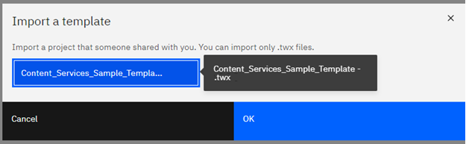

The template appears in the Templates list:

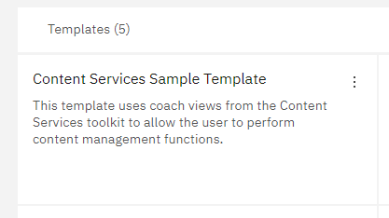

## Create an application from the template

Create an application instance from the template by clicking the “Create” link in the Applications view:

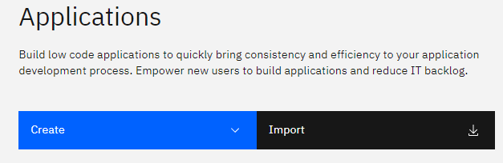

The following dialog will appear:

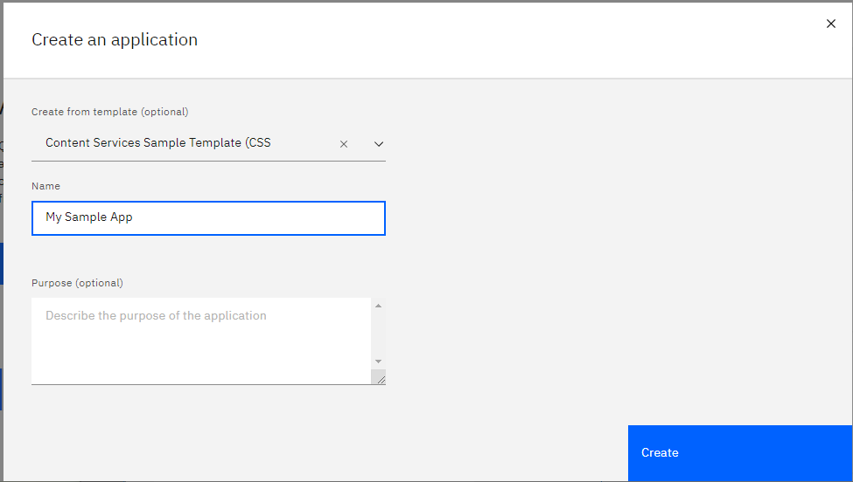

## Configuring the application

There are four views in the application (the Content List, Document Thumbnail, Content Properties and Document Viewer). You must configure each view with the name of the repository (object store) that you want to browse. Optionally, you can configure the Content List to either browse folders or to display search results. To configure the Content List, click first on the Content list, then on the Properties icon (gear) that appears just below the view:

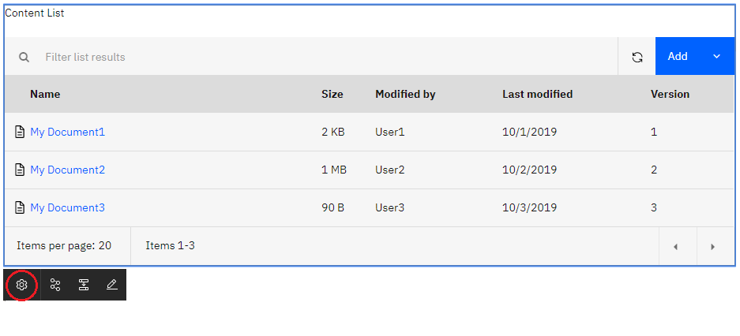

The Properties dialog opens. Next, select the name of the repository you would like to use:

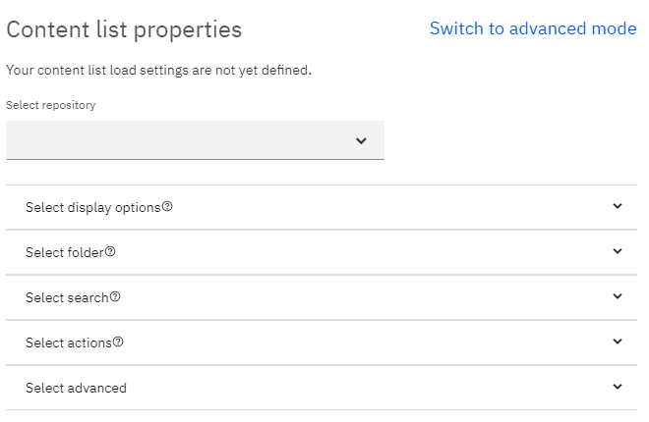

By default, the application browses the repository starting at the Root folder, allowing users to navigate the folders in the repository. This option is set in the Select folder section of the Configuration pane:

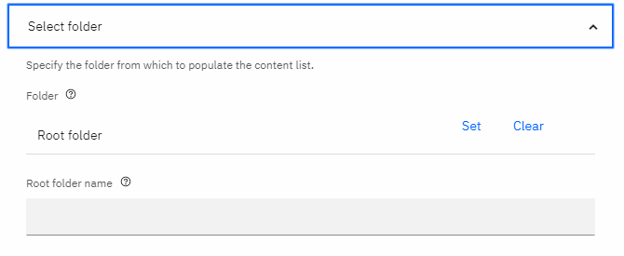

You can configure the application to browse starting at a different folder by selecting the Set option and navigating to the folder you would like to start your display.

You can also configure the application to display search results by entering search criteria in the Search section of the configuration pane (you must clear the folder in the Select folder section above):

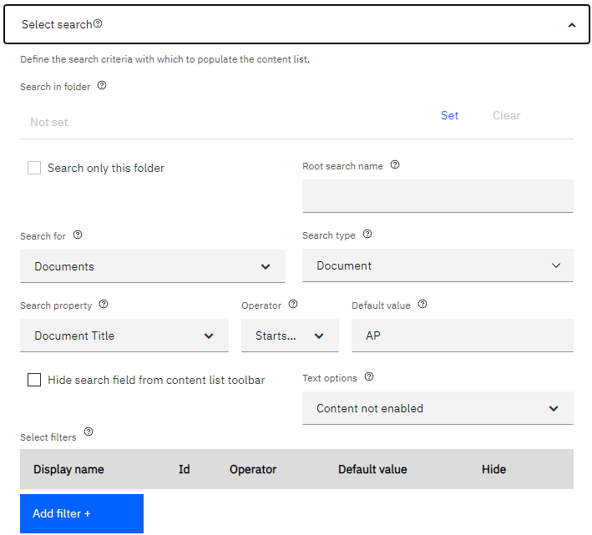

When both a folder and search criteria are specified, the folder has precedence and is used to display the contents of the folder.

When you are done configuring the Content List, click on the “OK” button in the lower part of the dialog to save and close it.

Next, click on the Document viewer, then on its Properties icon:

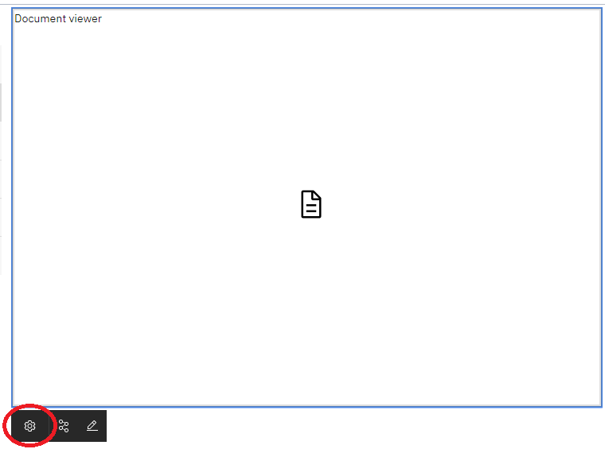

Click on the Configuration tab and enter the object store name as you did for the Content list:

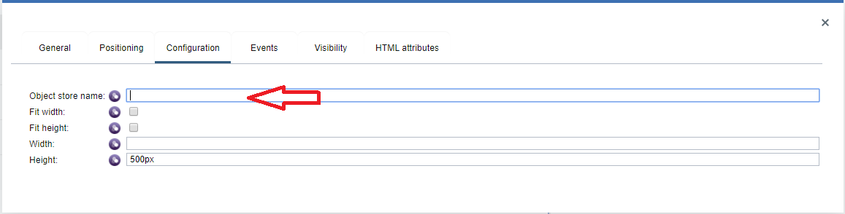

Close the properties dialog and repeat these steps to configure the repository (object store) name in the Document Thumbnail and Content Properties views.

## Save and publish your changes

Once all views are configured, click the check icon in the upper right part of the page to save your changes:

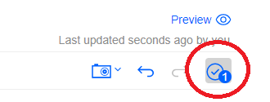

Then, click the Preview link in the upper right of the page to publish and run the application:

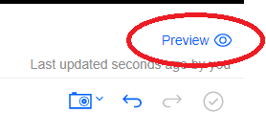

For more information about configuring other options in the Content list and integrating applications into Navigator, see the Content Services Toolkit GA document in the same GitHub location as this document.

## Using the sample application

The application browses the folder hierarchy in a FileNet Content Manager object store. To navigate into a folder, click the folder name link. To navigate up the folder hierarchy, use the breadcrumb at the top of the content list. To add new documents or folders, click the “Add” button on the toolbar of the content list:

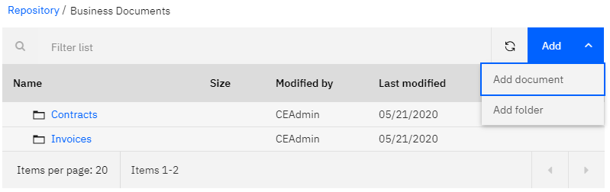

To display context menu for individual item, click on the button in the far right of a folder or document row:

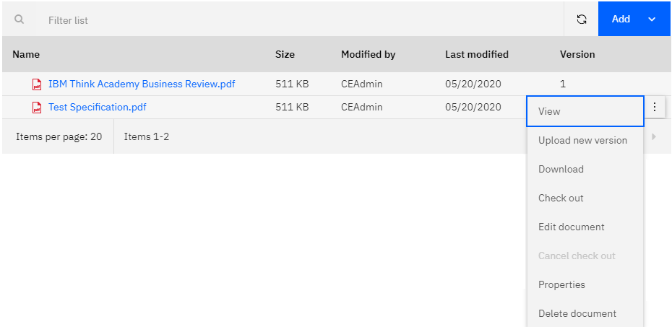

Clicking on the name of an item displays its properties in the Content Properties view on the right side of the window. Clicking the name of a document also displays the content of the document in the Document viewer in the lower part of the window. Properties may be edited and saved by clicking the buttons at the top of the properties view.

